Analyzing Social Sentiment Data to Determine Correlation with Cryptocurrency Price

Ripa Shah
University Of Arizona
MS in Data Science

Abstract -Emotional posts on social media, such as reddit and twitter, can consequently affect the behavior of crypto investors and the volatility of crypto prices. Thus, we could interpret cryptocurrency prices rely upon users’ posts and comments on social media platforms. It is one of the most popular methods to predict cryptocurrency prices using users’ sentiment. In this module, we collected and processed a dataset comprising 12 months of historical and live Reddit sentiment data for five major cryptocurrencies (Bitcoin, Ethereum, Solana, Dogecoin, and Cardano), cross-referenced with corresponding price data from Yahoo Finance to test above statement. The entire module of this analysis leveraged Azure Cosmos DB for scalable storage and PySpark for efficient, distributed data processing, including rigorous data cleaning and schema assignment. This project explores three algorithms: Random Forest, Long Short-Term Memory (LSTM), and Support Vector Machine (SVM).The primary objective is to forecast the one-month price of Bitcoin and Ethereum using two advanced machine learning techniques: Long Short-Term Memory (LSTM) and Support Vector Machines (SVM). Concurrently, a focused time series analysis will be implemented to demonstrate the precise correlation between current, previous-day, and next-day sentiment scores and cryptocurrency price dynamics.

Keywords-
sentiment analysis, cryptocurrency, Solana, Ethereum, Cardano

INTRODUCTION AND BACKGROUND
This research paper analyzes correlation between cryptocurrency prices and user sentiments. It is aiming to understand how public mood can fluctuate the cryptocurrency volatile market. Basically, it is collecting social site’s sentiment data (like reddit posts and comments) and crypto price data (like yahoo price). Using Reddit API and Yahoo Finance Prices, I’ve collected sentiment data and price data and stored those records into Azure CosmosDB database by implementing a python script. Once, I’ve 12 months of data from Reddit API and Yahoo Finance, I’m converting those records from Azure CosmosDB to pyspark. By using three main machine learning algorithms, it is training a sentiment score to predict crypto prices. My entire workflow has been demonstrated in the following diagram.

Yahoo Finance API
Reddit API
Retrieve data using Python Script
Store data into Azure CosmosDB
Perform data cleaning, Data Exploratory Analysis
PySpark
Implement LSTM, SVM and random forest algorithm to forecast cryptocurrency price

This study addresses several critical areas within cryptocurrency market analysis. Primarily, we aim to identify the optimal forecasting algorithm for Bitcoin and Ethereum price movements. Second, the research investigates the complex relationship between sentiment (current, previous-day, and next-day) and cryptocurrency prices to determine the influence of lagged and future public mood. Furthermore, the project provides a comparative analysis of data storage solutions, assessing the benefits of Azure Cosmos DB over traditional CSV file storage in this domain. Finally, we analyze the impact of rigorous data cleaning and exploratory analysis methodologies on the overall performance and accuracy of the utilized forecasting algorithms.

RELEVANT WORK
As we investigated these subjects for this project, I discovered a few websites and research articles that were helpful in my investigation of sentiment analysis and cryptocurrencies. Sentiment analysis of cryptocurrency price prediction approach was examined in the first study paper I came across, "Cryptocurrency Analysis: Price Prediction of Cryptocurrency Using User Sentiments and Quantitative Data," which integrated sentiment analysis with quantitative data. It investigates the combination of deep learning with machine learning methods, a field that has not been thoroughly studied before. Long Short-Term Memory (LSTM), Recurrent Neural Network (RNN), bidirectional LSTM (bi-LSTM), and Gated Recurrent Unit (GRU) are the four models that are investigated and optimized for the job in this research (Perera D., Lim J., Gunraku S. and Lim W. (2024)).

Another research paper that I found intriguing for this project is "Cryptocurrency Price Prediction Using Forecasting and Sentiment Analysis". This research report primarily focuses on how Twitter sentiment affects Bitcoin and Ethereum values. The study optimizes three machine learning approaches: Long Short-Term Memory (LSTM), Support Vector Machines (SVM), and Naïve Bayes (NB). It forecasts Bitcoin and Ethereum prices for three months using deep learning algorithms. The SVM method surpassed the NB algorithm with accuracy rates of 93.95% and 95.59%, respectively. (Alghamd, S., Alqethami, S., Alsubait T., & Alhakami, H., 2022).

METHODOLOGY
- Data Collection and Data Storage:
I’ve built a python script to build this dataset using Reddit API and Yahoo Finance. First, I’ve created reddit account and follow this link: https://www.reddit.com/prefs/apps. I have filled out following information:
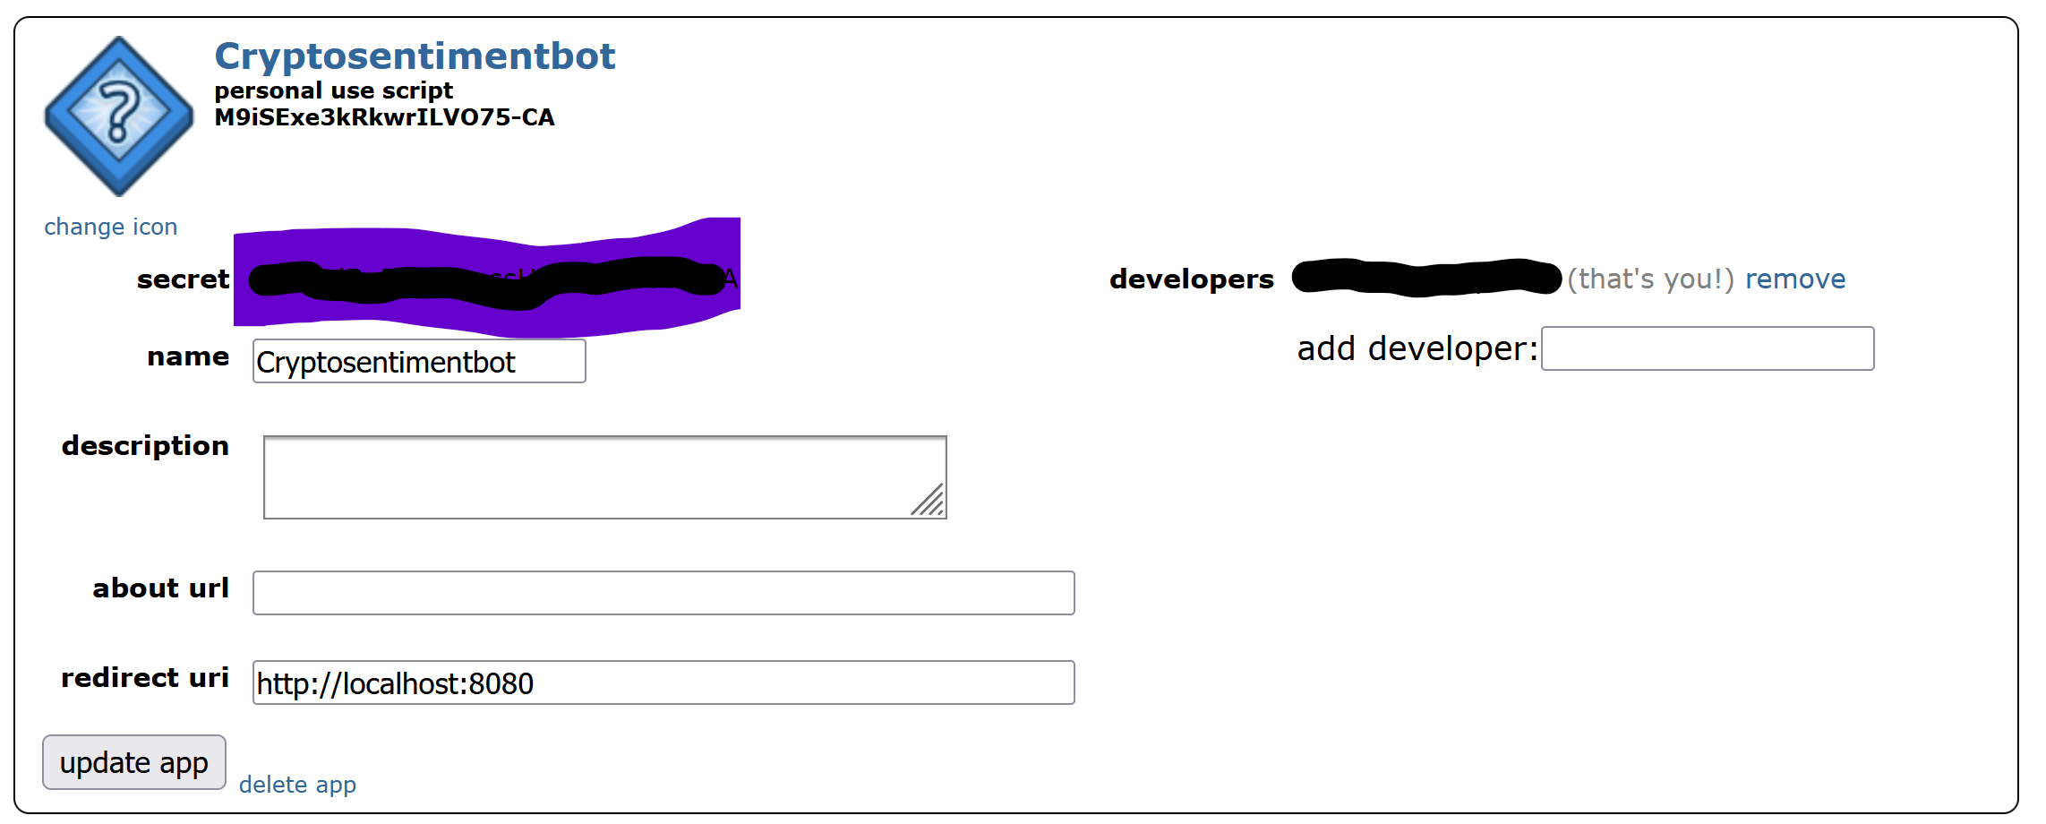
Fig A Reddit API setup from reddit

As per above figure, I’ve provided client_id, client_secret and user_agent information to initialize connection with above API in reddit-sentiment python script. Before initializing reddit sentiment, I’ve installed following libraries into python to insert reddit-sentiments.
Fig (B) Reddit API and Cosmos DB library installation
Azure Cosmos DB Storage Vs CSV:
1. Global distribution: NoSQL has multi-region write capabilities and automatic geo-replication, allowing applications to serve customers worldwide with low latency. CSV files are limited to specified storage places.
2. Indexing: NoSQL automatically indexes data, which improves query performance. Indexing CSV files must be done manually or using external tools, which can be hard and inefficient.

For data insertion process, I’ve created Azure CosmosDB account from https://portal.azure.com/#home. I’ve created a resource group and Azure Cosmos DB account. For details, please see Appendix A: Cosmos DB.
In Data Explorer, I’ve created a database called Reddit-Crypto. Likewise, I’ve created Crypto-Price and Reddit-Sentiment Container where I’ll be adding records using my developed python script
Appendix A: Cosmos DB. Before inserting records into Cosmos DB database from Cryptocurrency price python script, I’ve installed yahoo finance python library to get cryptocurrency data.
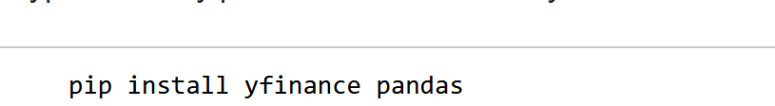Fig (F) yFinance Library installation
I’m using following configuration to insert records from Reddit API and Yahoo Finance API to Azure Cosmos DB. This entire process has been executed in visual studio code environment. To connect with Azure Cosmos DB portal, I need Cosmos URI, Cosmos Key, database id and container id.
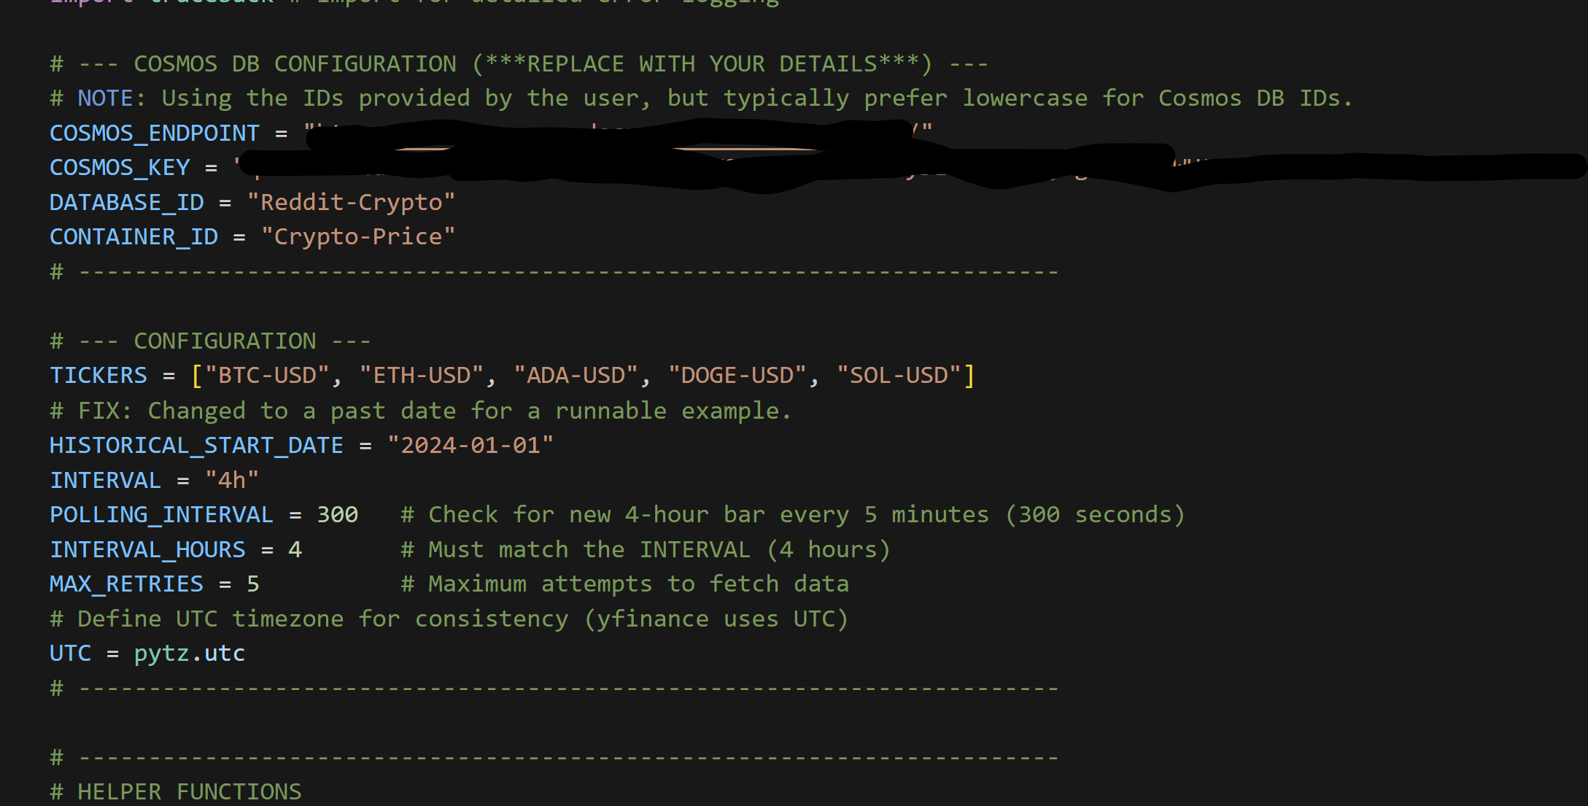
Fig G Cosmos DB Configuration
By utilizing Yahoo Finance API, I’ve selected timestamp, symbol, id and price fields into my python script to insert records into Cosmos DB Crypto-Price container Appendix B: python script
By utilizing Reddit API, I’ve generated sentiment-score using Vader Sentiment using my python script. Also, I’ve selected id, date, user_id, type, title, cryptocurrency, review, sentiment_score and partition_key_value to generate fields into Reddit-Sentiment container of Reddit-Crypto Azure Cosmos DB database. Appendix B: python script
In Cosmos DB containers including Reddit-Sentiment and Crypto-Price container, I’ve been collecting (historical and live) data for every four-hour interval. Appendix B: python script
- Database Connection and Network Access
Before retrieving records into PySpark, it is imperative to connect with Azure Cosmos DB account. Google Colab creates a dynamic IP address. Thus, we’re not able to set static IP address in Azure. As a result, I’ve set public network access to all networks.

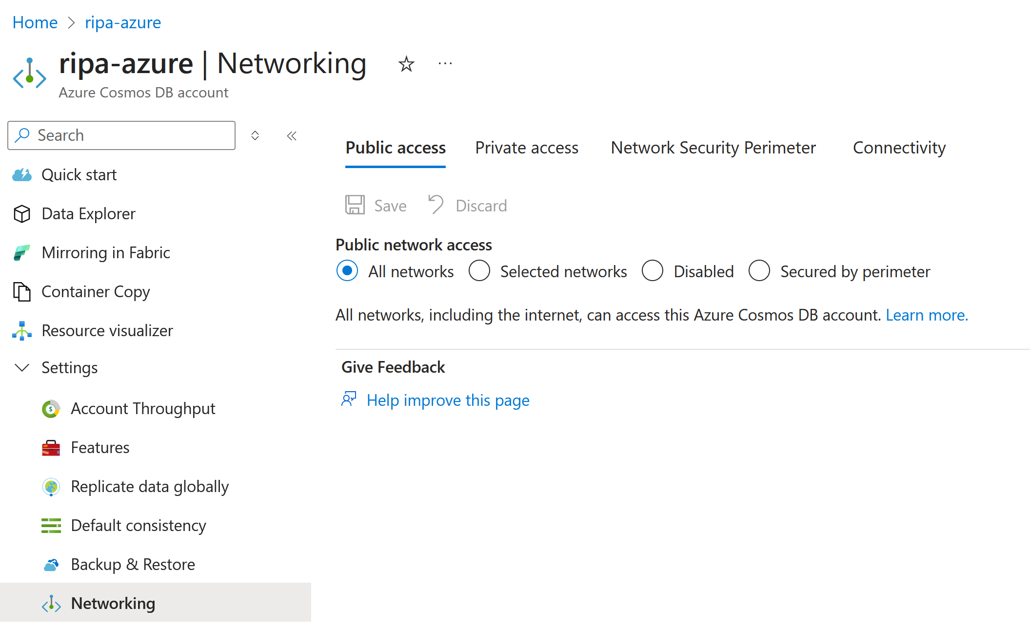
Fig (K) Database connection and Network Access

- Dataset:
Once it inserts data into Azure Cosmos DB database, I’m fetching those records using PySpark (Appendix C: Datasets). Basically, I’m using two datasets here.
(1) Crypto-Price Dataset
(2) Reddit-Sentiment Dataset.
Total number of rows for Reddit-Sentiment dataset is 22548. Total number of rows for Crypto-Price dataset is 11692.
Crypto-Price Dataset
Field name | Data Type
Timestamp | String
Price | Double
Symbol | String

Reddit-Sentiment Dataset
Field Name | Data Type
Date | String
User_id | String
Type | String
Title | String
Cryptocurrency | String
Review | String
Sentiment_score | Double

To execute Exploratory Data Analysis and machine learning algorithm selection, it is imperative to join these two datasets using date field. I’m considering date field as a primary key. However, when I inserted records using Cosmos DB database it has following keys.
        - For Crypto-Price containers, symbol and timestamps are considered as an id which was composite key. Because of that, I’m not getting any duplicate rows in Crypto-Price container.
        - For Reddit-Sentiment container, id field considered as a primary key. It was auto generated unique key. There will be a chance of getting a duplicate value in Reddit-Sentiment container.

- Data Preprocessing:
Data preprocessing, which involves manipulating, filtering, or augmenting data, is a crucial first step before analysis (Chism, G. (2025)).
In second module, once the data was retrieved from Azure Cosmos DB, the immediate next action was to assign a schema to the two resulting datasets. I then renamed the 'timestamp' column to 'date' in the Crypto-Price dataset to facilitate a seamless join with Reddit-Sentiment dataset later in the analysis. To prepare for analysis, I will apply a filter transformation on the sentiment_score to classify the data as neutral, positive, or negative. This classification will populate the new Sentiment_label column.
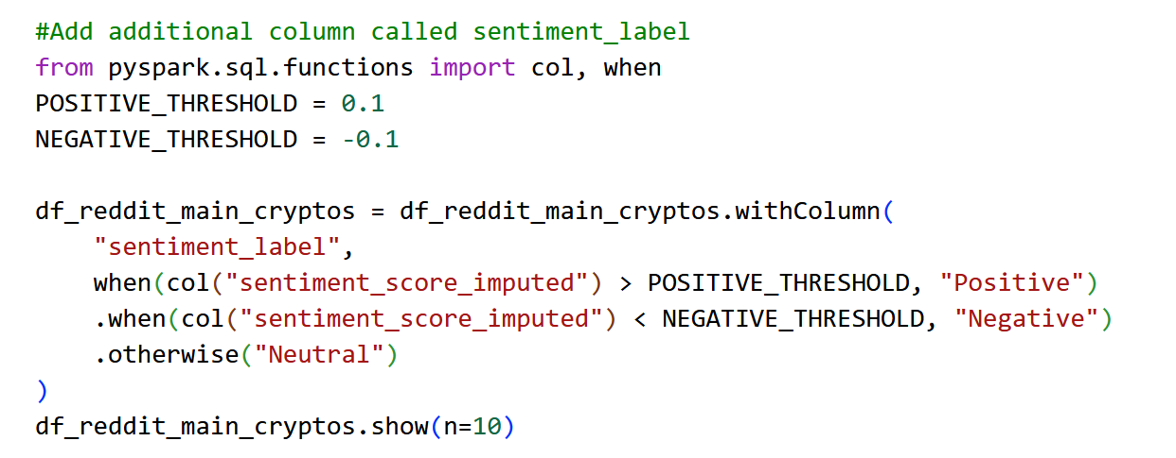
Fig (I) New column – Sentiment label
In the further analysis, I’ll need to rename symbol field of Crypto-Price dataset to join with Reddit-Sentiment dataset. I’ll be splitting data from the symbol field to retrieve only cryptocurrency abbreviation. Once I capture abbreviation, I’ll rename this new field as a cryptocurrency and remove the old symbol field. Following this new feature generation, I will proceed with the comprehensive data cleaning process.
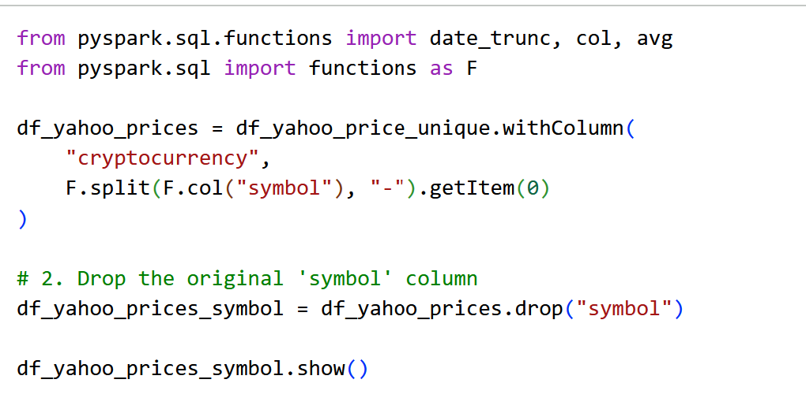
Fig (2) New column – Cryptocurrency

- Data Cleaning:
- Crypto-Price Container:
First, I’ll be removing duplicates from this dataset. As per section C. explanation, I do not have any duplicate values. For screenshot, please refer Appendix I. Data Cleaning

Like the previous checks, no null values were detected. This clean dataset was made possible by leveraging Azure Cosmos DB. For screenshot, please refer Appendix I. Data Cleaning.
- Reddit-Sentiment Container:
Similar to Crypto-Price container, I’ve also removed duplicates in this dataset. The remaining data are from 22548 to 22506. For screenshot, please refer Appendix I. Data Cleaning.
Second, I’ll be filling missing values with appropriate values. In that, I’ve implemented mean imputation for sentiment_score field. In statistics, imputation is the process of substituting values for missing data. Mean imputation involves replacing missing values with the arithmetic mean of non-missing values in the same variable. (Chism, G. (2025))
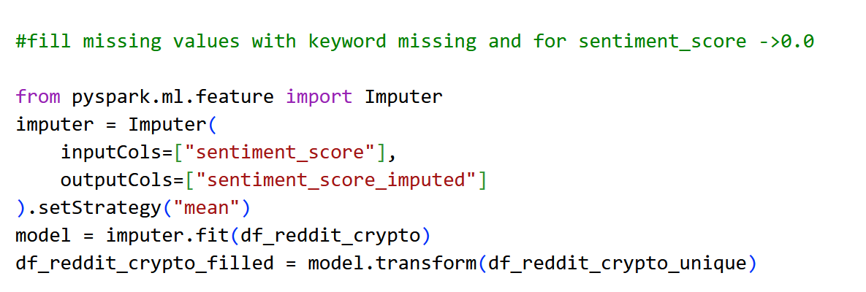
Fig (6) Mean imputation
For string fields, I’ve added missing keywords for the missing values. For screenshot, please refer Appendix I. Data Cleaning.
In addition, I’m checking whether my cryptocurrency has any remaining inessential values or not. For screenshot, please refer Appendix I. Data Cleaning.
As a result, I did not find any inessential values. In further analysis, the date field will be utilized as a common field to join the tables, so I’m checking whether date field has any null values or not.
Fig (9) Checking null values in date field
Consequently, the absence of null values indicate reddit-sentiment dataset is now clean. I am ready to continue data analysis.
- Exploratory Data Analysis:
Exploratory Data Analysis is a statistical approach to analyzing datasets to summarize their main characteristics, often using visual methods (Chism G. (2025))
        - Check time range of both dataset:
It is imperative to verify the time range of both datasets before performing data analysis. In this section, I’m finding maximum and minimum date of reddit-sentiment and crypto-price dataset. It will be helpful to select dates in further analysis. Please see Appendix G. Data Exploratory Analysis
I’m utilizing start date as 11/1/2024 to today’s date (12/4/2025)
2. Calculating Group Statistics: The implementation employs a group-by aggregation on the user ID column to derive user-level statistics. This process calculates the total review count and the total number of distinct titles for every user in the dataset.
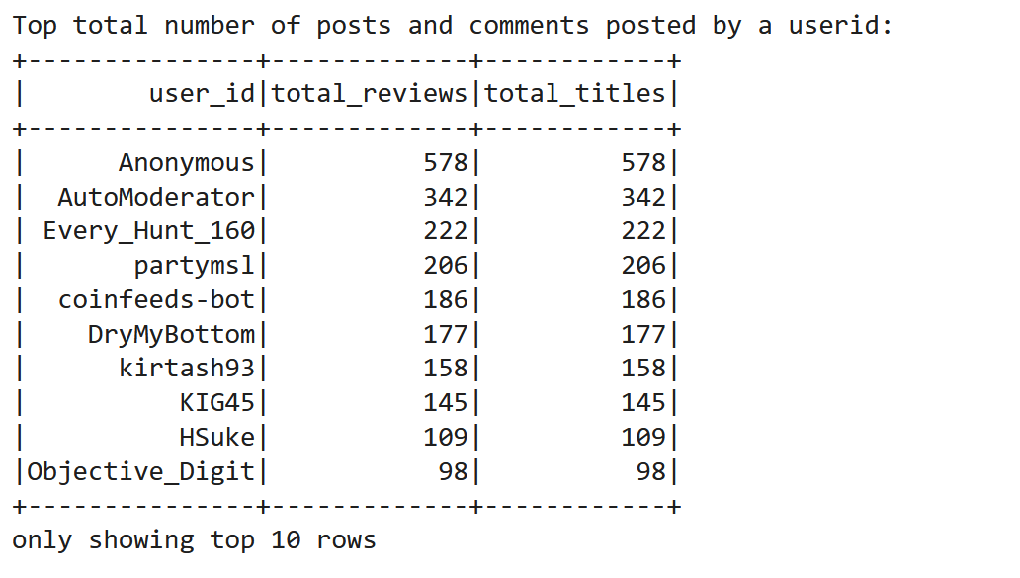
Fig (N) Total number of posts and comments posted by userid
Please refer Appendix D: Calculating Group statistics for more examples.
- Distribution with Sentiment Score:
In below fig (Q) depicts the distribution of sentiment score ratings from -0.5 to 0.25. We have highest number of positive sentiments. This dataset appears to contain mildly negative, neutral and positive sentiment.
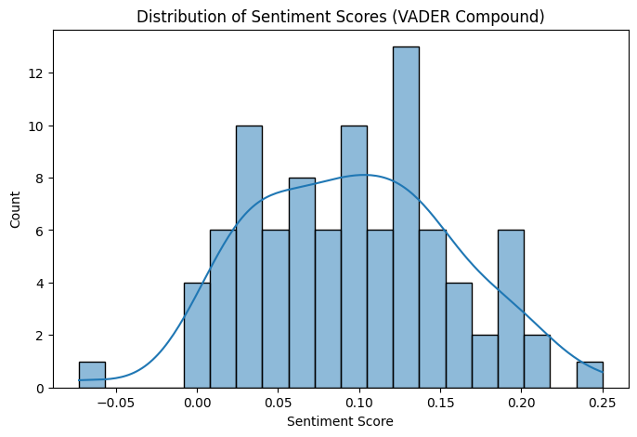
Fig (Q) Distribution of Sentiment Scores

- Total Reviews by cryptocurrency:
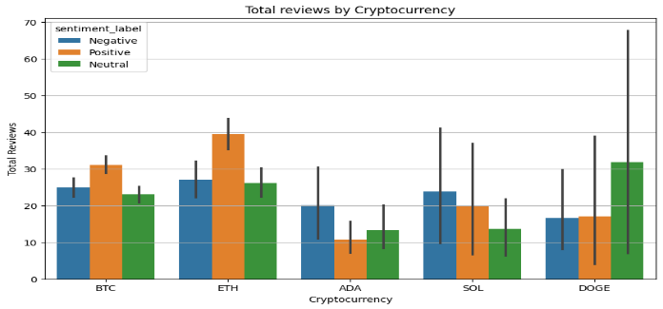
Fig (R) Total Reviews by Cryptocurrency
In Fig (R), it depicts reviews distribution by cryptocurrency and sentiment score. It clearly demonstrates BTC, ETH, ADA, SOL and DOGE coin’s positive, neutral and negative reviews. SOL has most negative reviews. ETH and DOGE has most positive reviews.
- Sentiment Distribution by Cryptocurrency (Comparative analysis):
In Fig (S), it depicts boxplot where you can sentiment score distribution by cryptocurrencies. In this analysis, each boxplot show median, the Interquartile range and whiskers. Points outside the whiskers are outliers.
Cryptocurrency | Median (approx) | Range | Outliers
BTH | 0.40 | -0.20 to 0.40 | No
ETH | 0.41 | -0.10 to 0.41 | Several outlier between -0.80 to -1
ADA | 0.35 | -0.30 to 0.35 | No
SOL | 0.40 | 0 to 0.40 | Yes. Several outlier between -0.65 to -1
DOGE | 0.20 | -0.40 to 0.20 | No

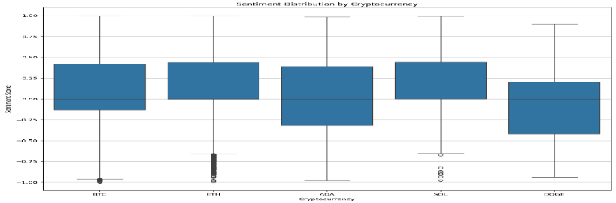
FIG (S) Sentiment Distribution by Cryptocurrency
- Cryptocurrency Count Analysis:
In Fig (T), it depicts number of specific comments and posts posted by unique users for cryptocurrency.
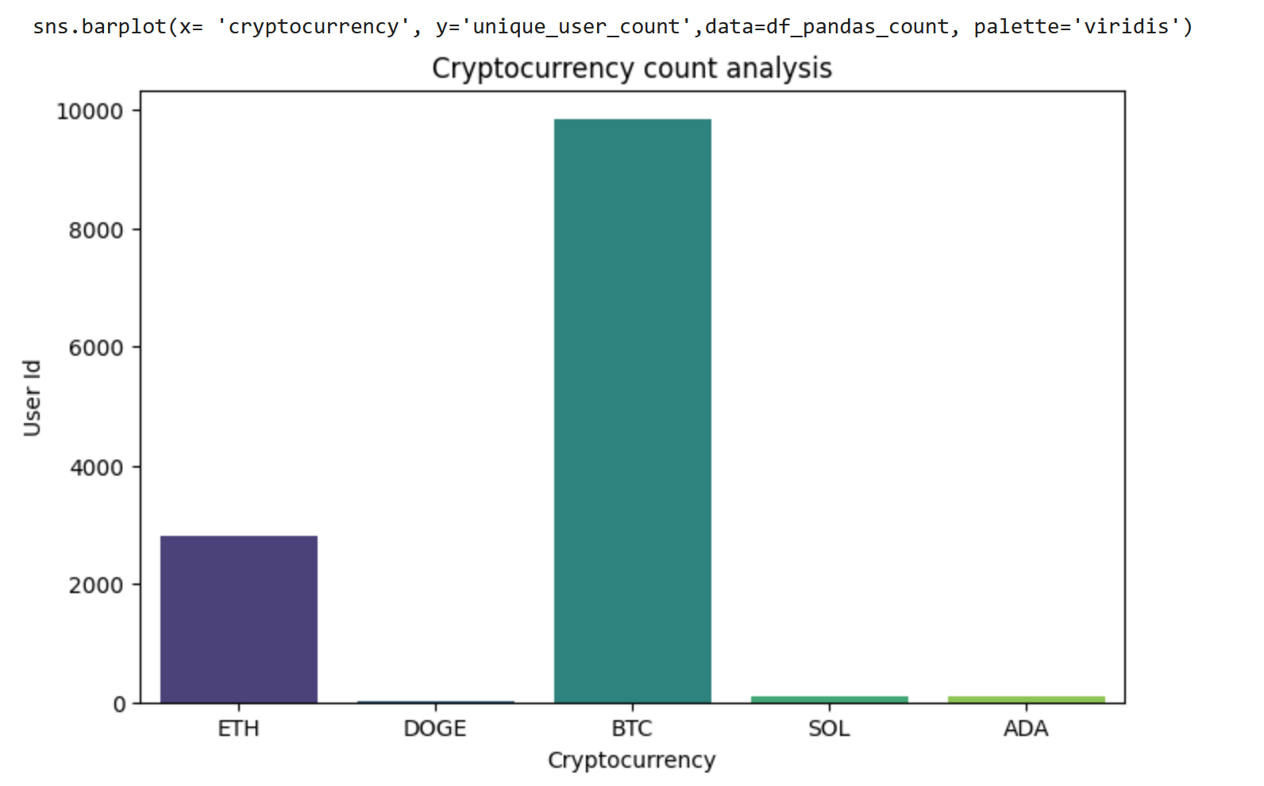
Fig (T) Cryptocurrency Count Analysis
- Calculate Daily Mean for sentiment and price:
It is imperative to balance the data to get an accurate result. I’ll be using daily mean joined and filtered dataset for further analysis. The start date will be 11/1/2024 and end date will be 12/4/2025
- Time Series Analysis:
Please refer Appendix E: Time Series Analysis for generic timeseries analysis which includes all cryptocurrency prices
In fig (X), there is no immediate, strong, and consistent visual correlation where a sharp drop in sentiment directly precedes a sharp drop in price, or vice versa. The sentiment line is often leading or moving independently of the price line. This reinforces the need for rigorous correlation analysis (like using lagged sentiment).
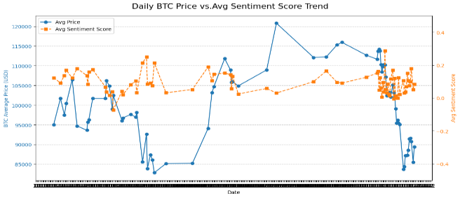
Fig (X) Daily BTC Price vs Avg Sentiment Score Trend

In Fig (Y), In lagged sentiment, the relation appears slightly more synchronous between sentiment score and price. That implies that previous days’ either positive or negative posts can influence the price volatility.
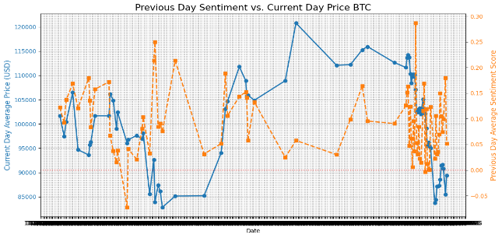
Fig (Y) Previous Day Sentiment VS Current Day Price
In Fig (Z), Current price does not strongly influence the very next day's sentiment in a clear, positive manner.
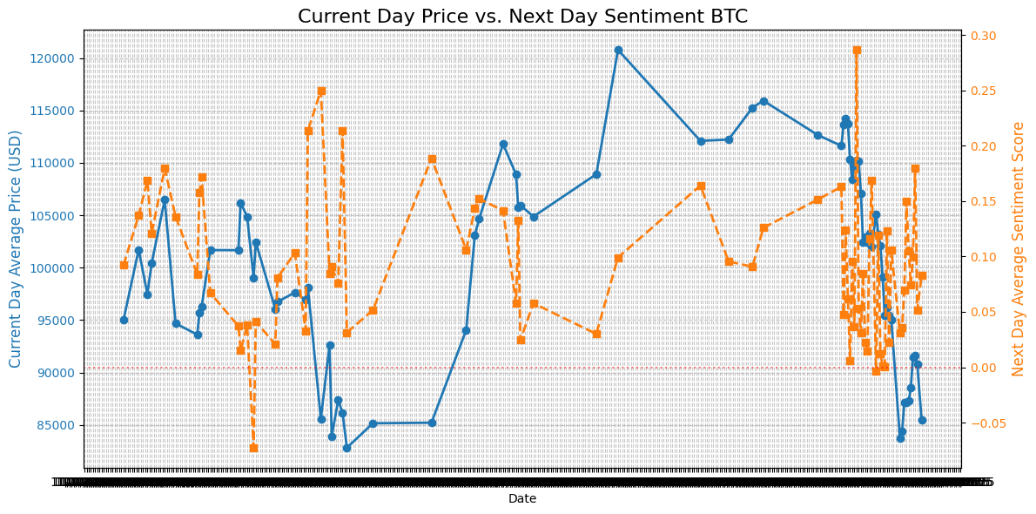Fig (Z) Current Day VS Next Day Sentiment
In Fig (Aa), (Ab), (Ac), it depicts current day vs current sentiment, previous day sentiment vs current price and next day sentiment vs current price for ETH

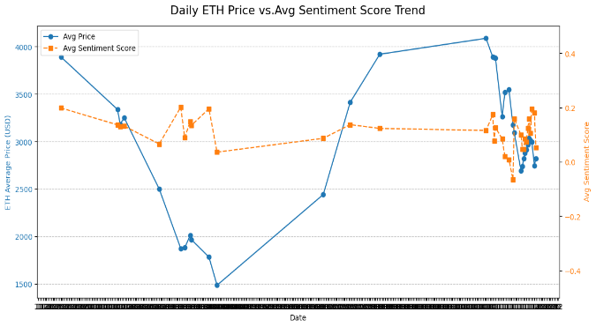
Fig (Aa) Current Price vs Sentiment score
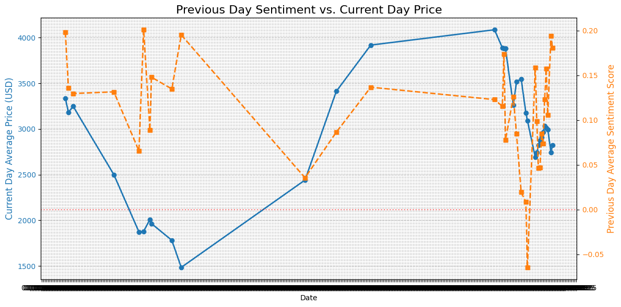
(Ab) Previous Day Sentiment VS Current Day Price
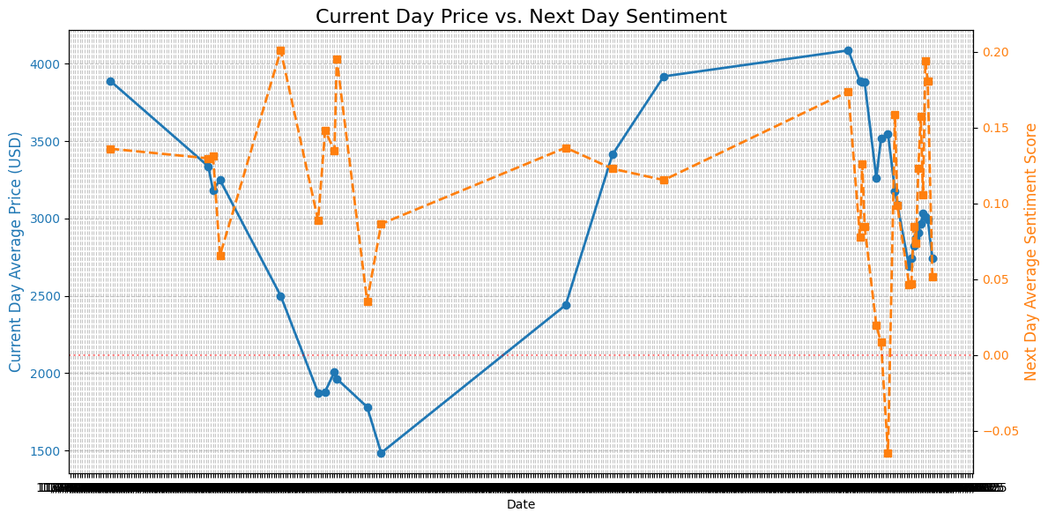
(Ac) Current Day Price VS Next Day Sentiment

- Correlation coefficient:
The correlation coefficient measures the strength and direction of a linear relationship between two variables, which is useful in assessing investment risks and optimizing portfolios. With values ranging from -1 to 1, it provides insights into how variables move together, which is critical for investors attempting to improve diversification and minimize volatility.
(1) BTC correlation coefficient for sentiment_score and price

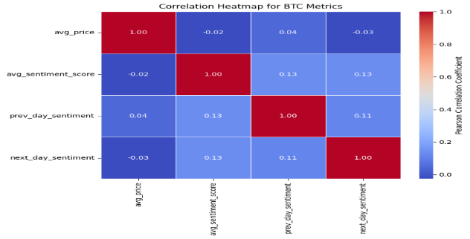
(Ad) BTC Correlation coefficient for sentiment_score and price
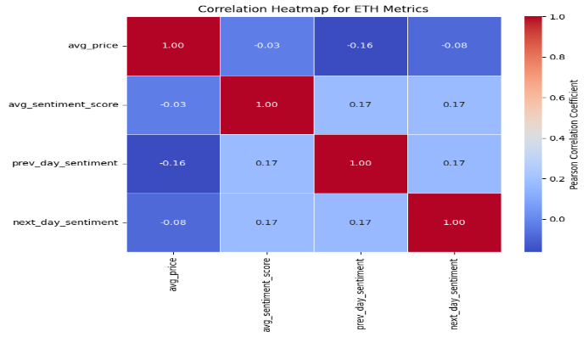
(Ae) ETH Correlation coefficient for sentiment score and price
The months with the largest negative sentiment correlated to drops in price and the months with the most positive sentiment also correlated to drops in price. Therefore, volume of data is a predictor of price drops. As volume of sentiment data decreased generally the price of the cryptocurrency decreased.

ALGORITHM MODEL
- Data Scaling:
Data scaling is a critical preprocessing step for effective Machine Learning and AI. It significantly improves the performance of the optimization algorithms used during the training of deep neural networks. The two most common techniques used are Normalization and Standardization. (Ahmed M. (2024)) I’ve implemented both mentioned scalers to improve performance. Standard scaler was not giving me expected result in compared to MinMax scaler while utilizing this scaler into random forest, SVM and LSTM. Consequently, I lean towards MinMax scaler.
- Stratified K-fold cross validation, random sampling and timeseriessplit
For definitions, please refer Appendix J: Stratified K-fold cross validation, random sampling and timeseries split. During the implementation of the Random Forest algorithm, I initially encountered an issue with random sampling. This approach led to an intermittent and critical failure where the training dataset received zero samples in certain folds, effectively halting the model's training process.
To resolve this issue and ensure reliable cross-validation, I switched the sampling method to a stratified 9-fold technique. This adjustment was essential to preserve the original class distribution across all training and testing folds, guaranteeing that the model always had sufficient and representative data for proper evaluation (Rohan, 2025). However, this algorithm result was not as expected. It gave me around 55% to 57% accuracy. I’ve also tried timeseriessplit and it was also producing the same result. I found that this is the best K-fold technique for this project. TimeSeriesSplit is a cross-validation technique that respects the order of time, always using older data for training and newer data for testing. This accurately simulates real-world forecasting where you predict future outcomes based on the past.
- Random Forest:
For definition, please refer Appendix H. Random Forest. In the following table (Af), I’m demonstrating the random forest performance for BTC and ETH. I’ve changed various hyperparameters including n_estimator, max_depth, n_features etc. However, it does not have any effect on ML performance.

Fold | Train | Test | Accu  racy | WA  Precision | WA  Recall | WA  F1 Score
Fold1 | 16 | 12 | 41.6% | 45% | 42% | 40%
Fold2 | 28 | 12 | 58.3% | 42% | 58% | 49%
Fold3 | 40 | 12 | 41.6% | 43% | 42% | 42%
Fold4 | 52 | 12 | 50% | 62% | 50% | 50%
Fold5 | 64 | 12 | 66.6% | 67% | 86% | 75%
Overall average |  |  | 51%
(Af) Random Forest for BTC
The model improves significantly over time, culminating in a 66.7% accuracy in the final fold. The Overall Average Accuracy across the four testing periods is 51.0%.

Fold | Train  Sample | Test  Sample | Accu  Racy | WA  Precision | WA  Recall | WA  F1-Score
Fold1 | 8 | 5 | 60% | 80% | 60% | 57%
Fold2 | 13 | 5 | 40% | 85% | 40% | 40%
Fold3 | 18 | 5 | 60% | 80% | 60% | 57%
Fold4 | 23 | 5 | 80% | 1% | 80% | 89%
Fold5 | 28 | 5 | 80% | 85% | 80% | 78%
Overall average |  |  | 64%
Fig (Ag) ETH Random Forest
The low Macro F1-score, particularly when the overall Accuracy is , confirms that the model's accuracy is often achieved by favoring the larger or easier-to-predict class, rather than by reliably distinguishing both outcomes. In summary, average accuracy is moderate.

- Support Vector Machine:
Support Vector Machine (SVM) is a supervised approach for classification and regression. It works by establishing the ideal hyperplane, which serves as a dividing border, to separate data points belonging to distinct classes. (Sasidharan, A. (2025))
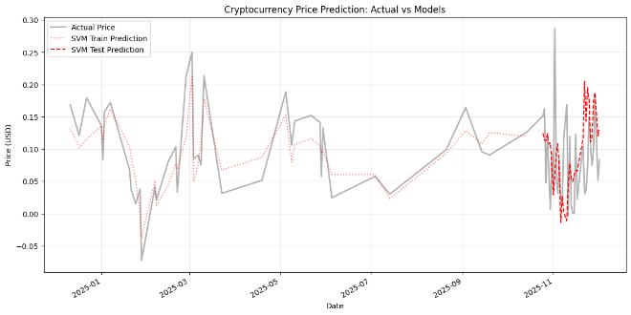
(Ag) BTC Cryptocurrency Price Prediction Actual Vs models
Class | Support | Precision | Recall | F1-score
Class 0 | 17 | 71% | 59% | 65%
Class 1 | 17 | 65% | 76% | 70%
Overall Average | 67.6%
(Ah) BTC SVM model evaluation
In fig (Ah), The model is slightly better at identifying actual up movements (High Recall for Class 1) but is more reliable when it predicts a down movement (High Precision for Class 0). The model correctly predicted the direction 67.65% of the time on the test set. In Fig (Ai), The SVM model struggles with the high-frequency, extreme volatility of this asset, especially in the testing period, where its prediction is significantly disconnected from the actual sharp drops
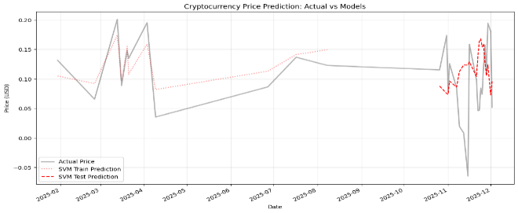
(Ai)ETH Cryptocurrency Price actual vs models SVM
Class | Support | Precision | Recall | F1-Score
Class 0 | 12 | 88% | 58% | 70%
Class 1 | 8 | 58% | 88% | 70%
Overall Accuracy | 70%
(Aj) ETH SVM model
The model is very good at identifying days that actually go up (88% recall for Class 1). However, when it predicts a day will go up, it is only correct 58% of the time. It has a high rate of False Positives (predicting Up when it was Down). When it predicts a Down day, it is highly reliable (88% precision for Class 0).
- Long Short-Term Memory:
Long Short-Term Memory (LSTM) is an improved form of recurrent neural networks (RNNs). LSTMs can detect long-term dependencies in sequential data, making them excellent for tasks such as language translation, speech recognition, and time series forecasting. Unlike typical RNNs, which use a single hidden state that is passed through time, LSTMs include a memory cell that stores information for lengthy periods of time, addressing the difficulty of learning long-term dependencies. (Chug, A. (2025))
In the following figure, I’m predicting price using LSTM. The accuracy of this ML is 67.7%. I’m seeing synchronization between actual price and predicted price from mid-October to December.

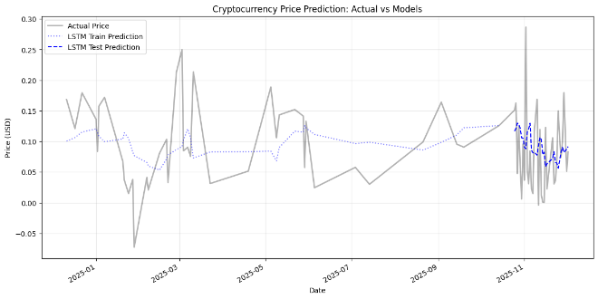
(Ak) BTC Cryptocurrency Price Predictions Actual Vs model

Class | Support | Precision | Recall | F1 score
0 | 17 | 69% | 65% | 67%
1 | 17 | 67% | 71% | 69%
Overall average | 67.6%
(Al)BTC LSTM model
The model's performance metrics are very similar across both classes, and the macro avg equals the weighted avg (). This confirms the model is not suffering from class imbalance and treats both upward and downward movements equally.

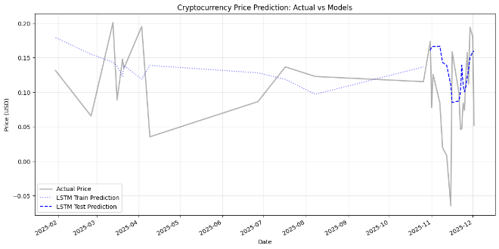
(Am) ETH Cryptocurrency Price Predictions Actual Vs model
Class | Support | Precision | Recall | F1-score
Class 0 | 11 | 86% | 55% | 67%
Class 1 | 8 | 58% | 88% | 70%
Overall Average | 68.4%
(An) ETH LSTM model
In simpler terms: If the market went up, the model almost certainly predicted it, but it also incorrectly predicted 'Up' when the market went down.

- Forecast for 3 month Price for LSTM and SVM:
Below (Ao) fig illustrates that its prediction/forecast using two machine learning models, LSTM and SVM, which appear to incorporate "Next Day Sentiment" as a feature.
=====================================
STARTING 3-MONTH FORECAST (90 days)
Forecast Period: 2025-12-02 to 2026-03-01
Simulated future feature (Next Day Sentiment, scaled): 0.4267
=====================================

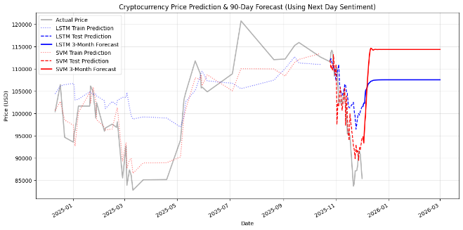
(Ao) Forecast for 3 months Price for LSTM and SVM BTC

In Fig (Ao), LSTN 3 month forecast predicts the price will stabilize and hold steady at approximately 107,500 USD.Similarly, SVM 3 month forecast Predicts a sharp upward rebound, stabilizing at approximately 114,500 USD.
======================================
STARTING 3-MONTH FORECAST (90 days)
Forecast Period: 2025-12-02 to 2026-03-01
Simulated future feature (Next Day Sentiment, scaled): 0.5921
======================================

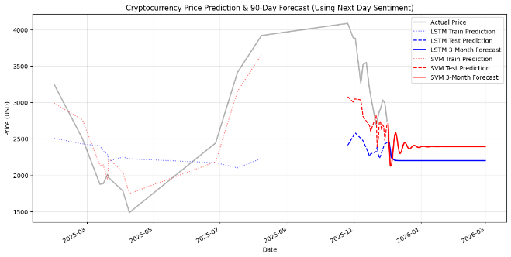
(Ap) ETH 3 month forecast for LSTM and SVM
In fig (Ap), Both models predict the price will settle into a new, stable range significantly below the historical peak, with the SVM model having a slightly higher forecast.

CONCLUSION
In summary, this research focused on following key items:
(1) Robust data storage solution: Reddit-sentiment and crypto-price live data has been stored into Azure Cosmos DB environment. It resolved indexing issues and static storage.
(2) Data cleaning and data preprocessing are crucial to ensure data quality and data synchronization.
(2) time series analysis: According to timeseries analysis of BTC, previous day sentiment is positively correlated with cryptocurrency price. However, ETH previous day sentiment and avg sentiment score are negatively correlated with cryptocurrency prices.
(3) ML Algorithms: After too much shuffling, I’ve used timeseries split to balance the dataset in random forest algorithm. Moreover, I’ve utilized MinMax scaler for all ML algorithms. For BTC, I found 51% of accuracy for random forest and 64% accuracy for ETH. I found 67.6% accuracy for BTC and 70% accuracy for ETH in SVM model. For LSTM, the BTC accuracy is 67.6% and ETH accuracy is 68.4%. For 3 month forecast, I’ve noticed that SVM is performing better compared to LSTM.

REFERENCES
(1) Perera D., Lim J., Gunraku S. and Lim W. (2024) Cryptocurrency Analysis: Price Prediction of Cryptocurrency Using User Sentiments and Quantitative Data. In Proceedings of the 16th International Conference on Agents and Artificial Intelligence - Volume 3: ICAART; ISBN 978-989-758-680-4, SciTePress, pages 210-217. DOI: 10.5220/0012315100003636
(2) Chism, G. (2025) Data Preprocessing. Info 511- https://datasciaz.netlify.app/slides/06-preprocessing.html#/title-slide
(3) Chism, G. (2025) Data Exploratory Analysis. Info 511- https://datasciaz.netlify.app/slides/04-eda.html#/title-slide
(4) Alghamdi, S., Alqethami, S., Alsubait3, T., Alhakami, H. (2022, October) Cryptocurrency Price Prediction using Forecasting and Sentiment Analysis. International Journal of Advanced Computer Science and Applications (IJACSA) https://thesai.org/Publications/ViewPaper?Volume=13&Issue=10&Code=IJACSA&SerialNo=105
(5) Aaqilah,(2023, April) Implementation of Long Short-Term Memory(LSTM). Medium - https://medium.com/@pennQuin/implementation-of-long-short-term-memory-lstm-81e35fa5ca54
(6) Arthur F N (2025, Feb) Random Forest and Technical Analysis to predict BITCOIN price. Medium - https://medium.com/@arthurfn/random-forest-and-technical-analysis-to-predict-bitcoin-price-0b3a30126901
(7) Ganegedara T. (2024, December) Stock Market Predictions with LSTM in Python – DataCamp - https://www.datacamp.com/tutorial/lstm-python-stock-market
(8) Fernando J. (2025, August) Understanding the Correlation Coefficient: A Guide for Investors -Investopedia - https://www.investopedia.com/terms/c/correlationcoefficient.asp
(9) Shafi, A. (2025, October) Random Forest Classification in Python With Scikit-Learn: Step-by-Step Guide (with Code Examples). Datacamp - https://www.datacamp.com/tutorial/random-forests-classifier-python
(10) Punyakeerthi BL (2024. June) Understanding Feature Scaling in Machine Learning. Medium - https://medium.com/@punya8147_26846/understanding-feature-scaling-in-machine-learning-fe2ea8933b66
(11) Ahmed M. (2024, August) Deep Learning 101: Lesson 1: Data Scaling. Medium - https://muneebsa.medium.com/deep-learning-101-lesson-1-data-scaling-9f7fa9d42de8
(12) Moore, David S. (2007), The Basic Practice of Statistics, fourth edition, Freeman - https://web.ma.utexas.edu/users/mks/statmistakes/SRS.html
(13) Rohan (2025, July), Stratified K Fold Cross Validation, geekforgeeks - https://www.geeksforgeeks.org/machine-learning/stratified-k-fold-cross-validation/
(14) Sasidharan, A. (2025, November) Support Vector Machine (SVM) Algorithm – Geekforgeeks. https://www.geeksforgeeks.org/machine-learning/support-vector-machine-algorithm/
(15) TimeSeiesSplit – Scikitlearn - https://scikit-learn.org/stable/modules/generated/sklearn.model_selection.TimeSeriesSplit.html
(16) Chug, A. (2025, October) What is LSTM - Long Short Term Memory? GeekforGeeks. https://www.geeksforgeeks.org/deep-learning/deep-learning-introduction-to-long-short-term-memory/
VIII ACKNOWLEDGMENT
We would like to thank our professor, Seokjun Youn for his guidance and feedback on our project.

APPENDICES

Appendix A: Cosmos DB
A. Cosmos DB Account Creation:
https://portal.azure.com/#home. I’ve created a resource group and Azure Cosmos DB account.
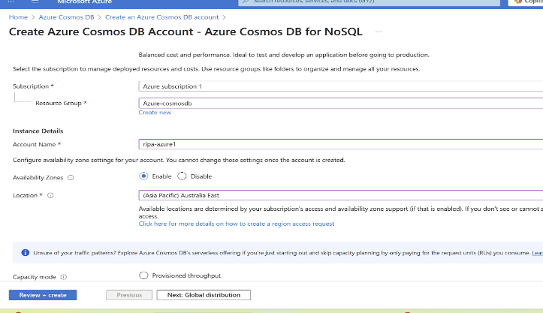
Fig C Azure Cosmos DB Account Creation

In Fig C, I’ve provided existing resource group name, unique account name and location.
Once deployment is successful, I’m able to see following screen. 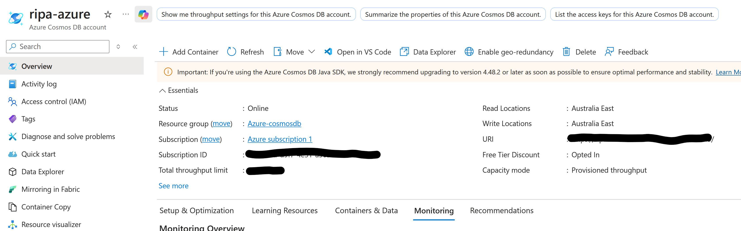

Fig D Azure- CosmosDB Account Overview

In Data Explorer, I’ve created a database called Reddit-Crypto. Likewise Fig E, I’ve created Crypto-Price and Reddit-Sentiment Container where I’ll be adding records using my developed python script:

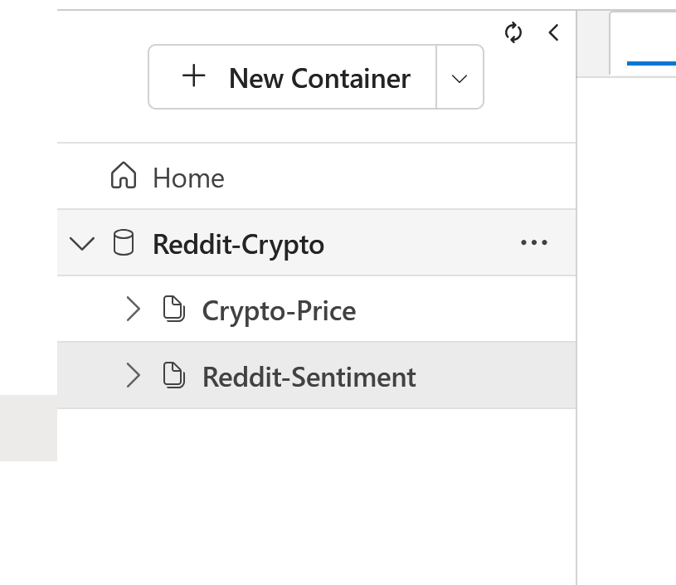
Fig E. Azure-CosmosDB Database and container

Before inserting records to CosmosDB database from Cryptocurrency price python script, I’ve installed yahoo finance python library to get cryptocurrency data.

Fig (F) Yahoo Finance library installation

Appendix B: python script
B. Selecting fields into python to insert into Cosmos DB
By utilizing Yahoo Finance API, I’ve selected timestamp, symbol, id and price fields into my python script to insert records into CosmosDB Crypto-Price container.
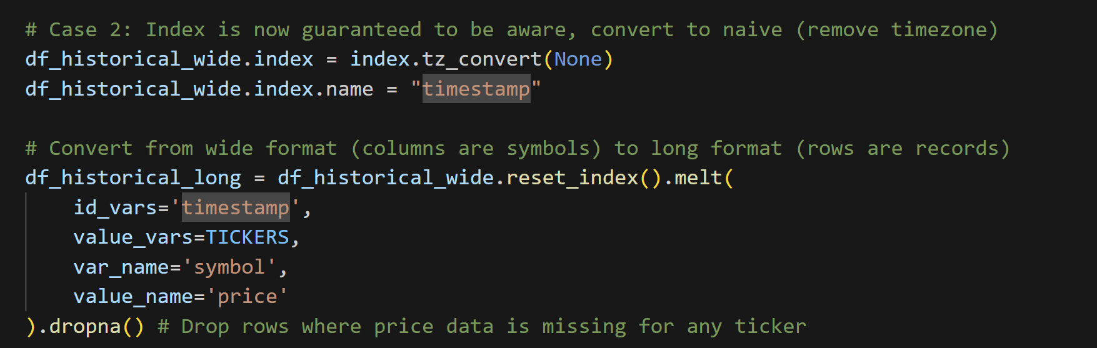
Fig (H) Understanding fields into Crypto-Price Python Script

By utilizing Reddit API, I’ve generated sentiment-score using vaderSentiment. Also, I’ve selected id, date, user_id, type, title, cryptocurrency, review, sentiment_score and partition_key_value to generate fields into Reddit-Sentiment container of Reddit-Crypto Azure Cosmos DB database.
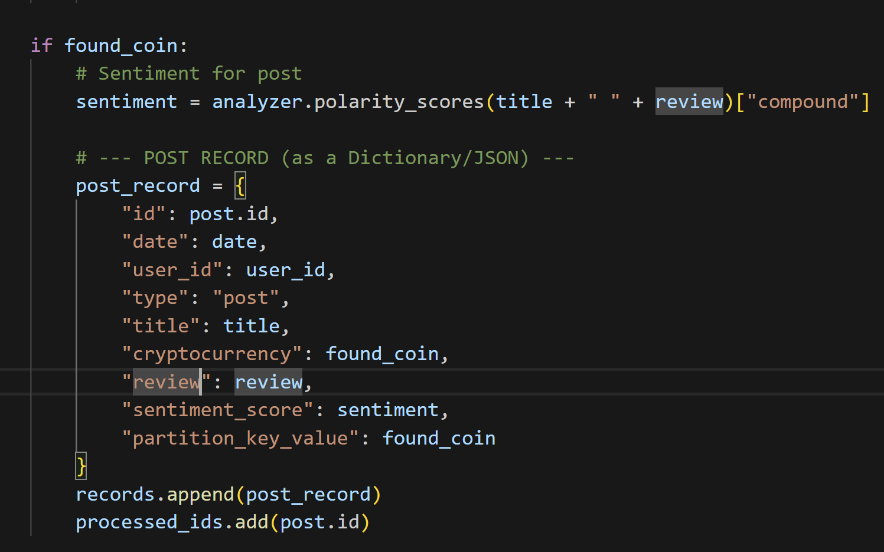
Fig (I) Understanding fields into Reddit-Sentiment Python Script

In Cosmos DB containers including Reddit-Sentiment and Crypto-Price container, I’ve been collecting (historical and live) data for every four-hour interval.

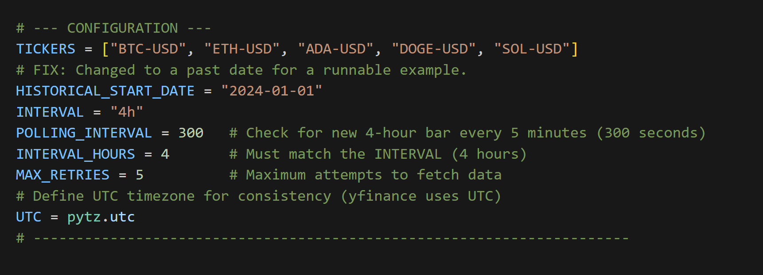
Fig (J) Chosen Interval to fetch records

Appendix C: Datasets
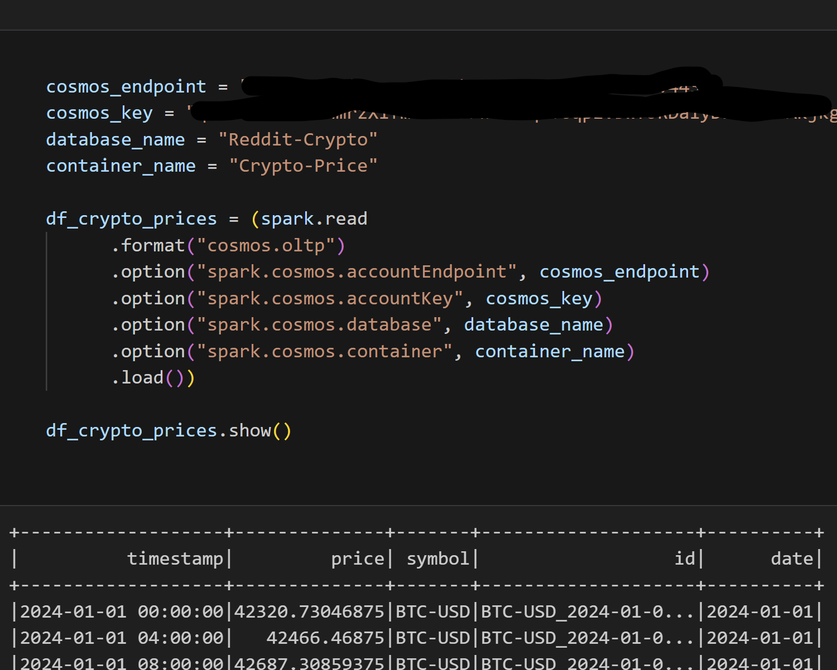
Fig (L) CosmosDB to PySpark Conversion

Appendix D: Calculating Group statistics
Total number of unique users who have posted comments and post for cryptocurrency:
This is another example of group by transformation on cryptocurrency and type to calculate unique users who posted posts and comments on cryptocurrencies. 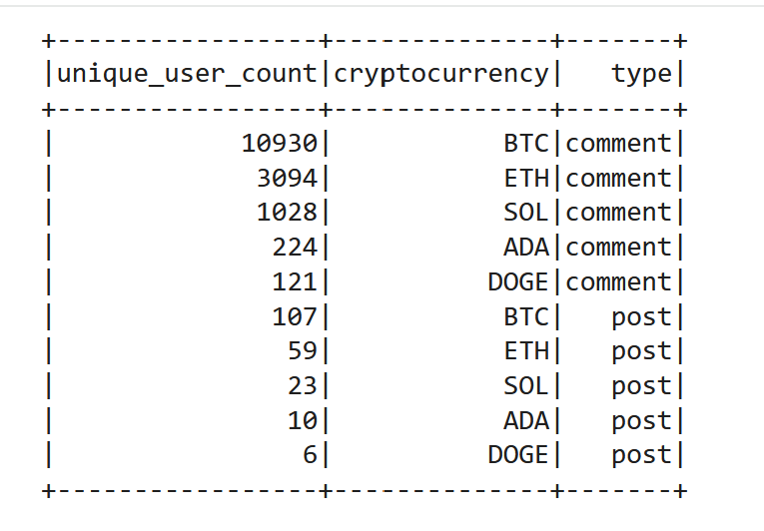
Fig (O) Total number of unique users count by cryptocurrency and type

Similarly, in fig (P), I’m counting users who have posted comments and posts on specific cryptocurrencies.
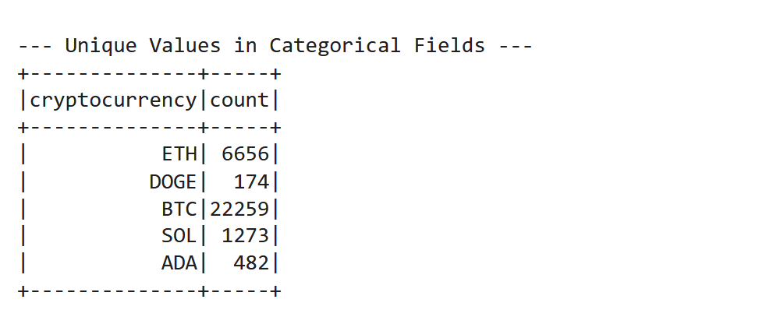
Fig (P) Total counts for cryptocurrency

Appendix E: Time Series Analysis

I’m using start date from 10/24/2025 to 11/24/2025 to get clear result for fig U,V and W.
In Fig (U), the first plot interprets price volatility. How much does the average price fluctuate daily? The second plot interprets sentiment score. Public Mood: Whether the public mood is generally positive (above 0), negative (below 0), or neutral (around 0). Correlation: How closely the peaks and troughs in sentiment align with the peaks and troughs in price
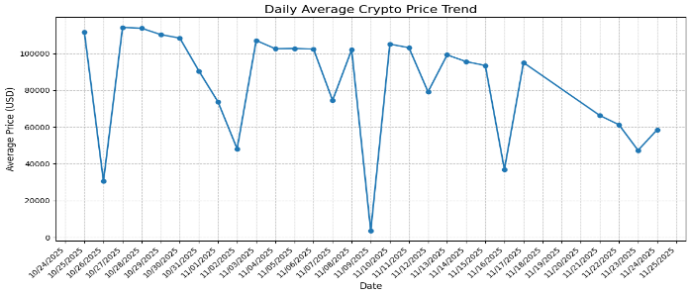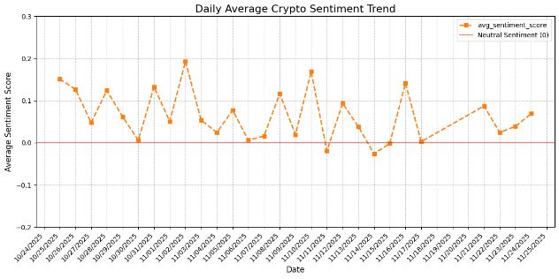
Fig (U) Daily Crypto Price Trend and Sentiment Trend
According to Figure V, the lagged sentiment (previous day's sentiment) exhibits a stronger correlation with cryptocurrency price fluctuations compared to the correlation observed with concurrent (current day) sentiment.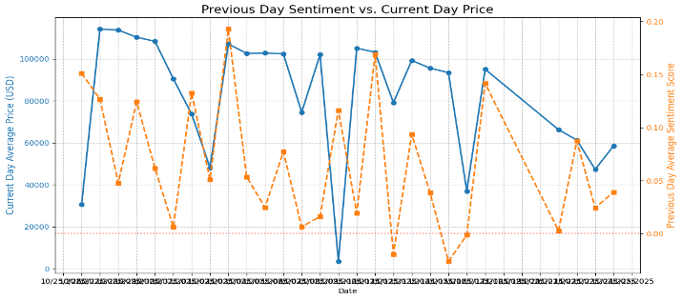

Fig (V) Previous Day Sentiment Vs Current Day Price
According to Figure (W), the next day’s sentiment exhibits a stronger correlation with cryptocurrency price as well. This was generic chart. It will not give an exact correlation for cryptocurrency price.
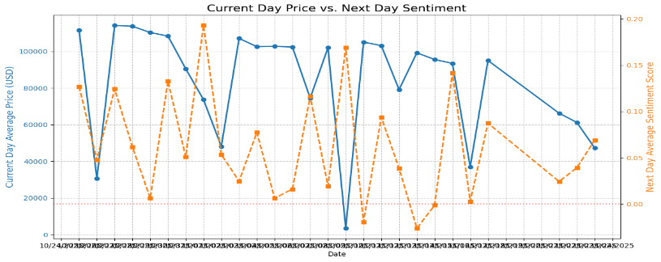
Fig (W) Next day Sentiment vs Current Day Price

Appendix F: General Difficulties
The biggest challenge was migrating from our initial CSV data source to Azure Cosmos DB. First, just getting the connection working was a headache; I spent a significant amount of time (10 hour) troubleshooting the Maven JAR files needed for the PySpark connector.
The second part of the Cosmos DB issue was networking: Google Colab's dynamic IP address kept changing, so my initial security plan to whitelist a static IP address failed. I eventually had to simplify security and allow public access to DB to proceed.
Also, since this was my first time with PySpark, I often defaulted to Pandas syntax, which generated a lot of errors. It was a steep learning curve! On the data side, the original CSV file had duplicate date that severely cut down our usable data, but luckily, migrating to Azure Cosmos DB fixed that issue entirely, giving us plenty of data to work with.
Optimizing the models for accuracy was a key challenge. For the LSTM and SVM models, I tried different scalers, and then I spent time adjusting the static date split between my training and test data. That iterative process finally got the models to a respectable 71% accuracy.
For the Random Forest model, the initial random split logic was failing—it was sometimes creating folds with zero samples for training. To fix this, I switched to timeSeriesSplit is a cross-validation technique that respects the order of time, always using older data for training and newer data for testing. This accurately simulates real-world forecasting where you predict future outcomes based on the past.

Appendix G. Data Exploratory Analysis

Check time range of both dataset: It is imperative to verify the time range of both datasets before performing data analysis. In this section, I’m finding maximum and minimum date of reddit-sentiment and crypto-price dataset. It will be helpful to select dates in further analysis. Please see Appendix G
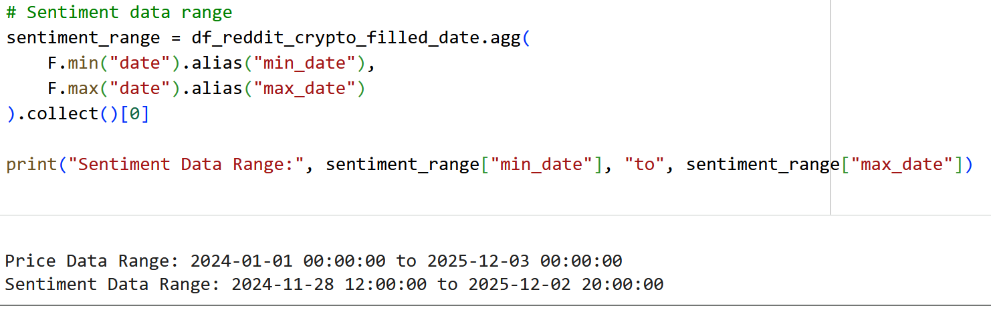
Fig (M) Check time range of both dataset

Appendix H. Random Forest
(1) Ensemble Training: Like gathering experts from different fields to provide varied insights, the model creates multiple Decision Trees. Each tree is trained independently on a random subset of the total data and features (a process known as Bagging).
(2) Individual Prediction: Each Decision Tree acts as a single Expert, offering an independent opinion based on the specific data it was trained on. This means each tree generates an individual prediction for the input data.
(3) Final Prediction (Classification): For classification problems, the process mimics experts voting to determine the final outcome. The model collects the predictions from all trees and outputs the mode (the most frequent result) as the final classification. (Shafi, A. (2025)).

Appendix I. Data Cleaning
- Crypto-Price Container:
First, I’ll be removing duplicates from this dataset. As per section C. explanation, I do not have any duplicate values.
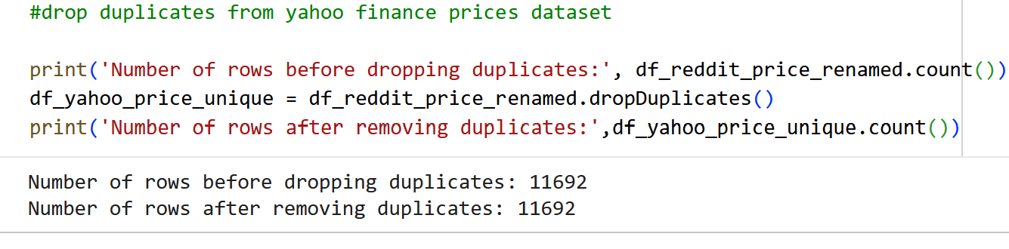
Fig (3) Removing Duplicates

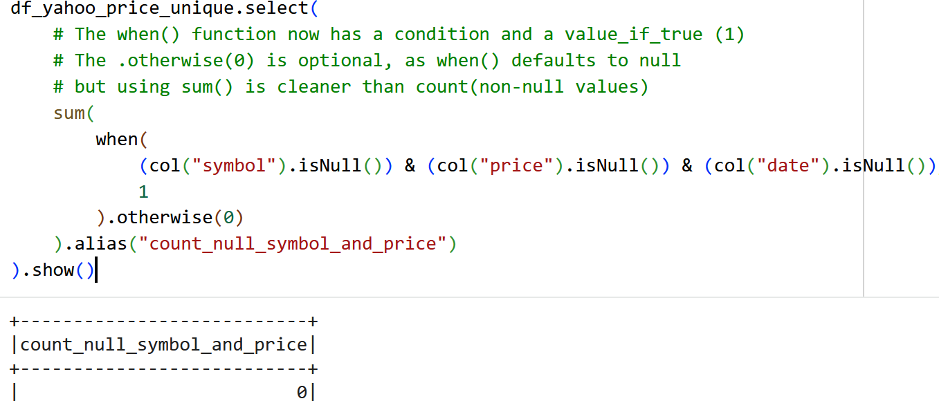

Fig (4) Count null values

Like the previous checks, no null values were detected. This clean dataset was made possible by leveraging Azure Cosmos DB.

- Reddit-Sentiment Container:
Similar to Crypto-Price container, I’ve also removed duplicates in this dataset. The remaining data are from 22548 to 22506.
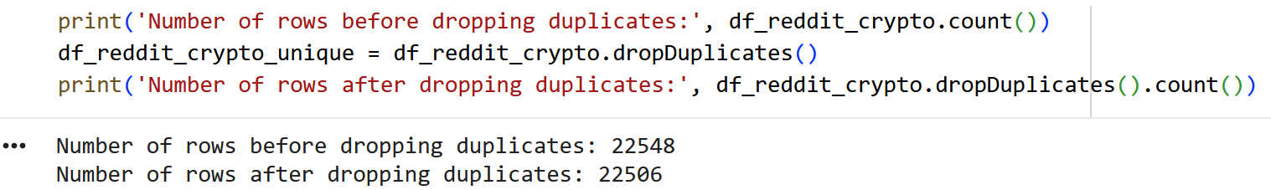
Fig (5) Removing duplicates

Second, I’ll be filling missing values with appropriate values. In that, I’ve implemented mean imputation for sentiment_score field. In statistics, imputation is the process of substituting values for missing data. Mean imputation involves replacing missing values with the arithmetic mean of non-missing values in the same variable. (Chism, G. (2025))


Fig (6) Mean imputation

For string fields, I’ve added missing keywords for the missing values.
Fig (7) Filling missing values with missing keyword

In addition, I’m checking whether my cryptocurrency has any remaining inessential values or not.
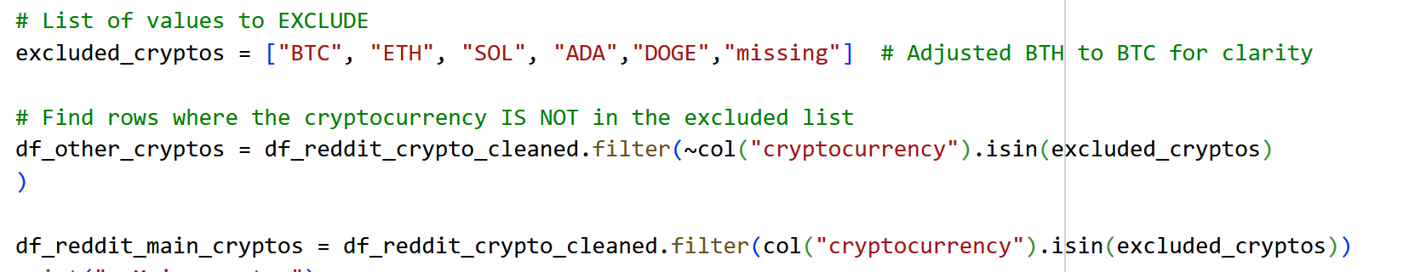
Fig (8) identifying the main cryptos and excluding inessential values in cryptocurrency field
As a result, I did not find any inessential values. In further analysis, the date field will be utilized as a common field to join the tables, so I’m checking whether date field has any null values or not.
Fig (9) Checking null values in date field
Consequently, the absence of null values indicate reddit-sentiment dataset is now clean. I am ready to continue data analysis.

Appendix J: Stratified K-fold cross validation, random sampling and timeseries split
Random Sampling: A simple random sample (SRS) of size n consists of n individuals from the population chosen in such a way that every set of n individuals has an equal chance to be the sample selected (Moore, D. (2007))
Stratified K-fold cross validation: Stratified K-Fold Cross-Validation is an improved method for evaluating machine learning models, particularly crucial for classification problems where the class distribution is imbalanced (unevenly distributed). It builds upon standard K-Fold Cross-Validation by employing stratification. This technique ensures that the original proportion of each class is accurately maintained across every fold (subset) created.

